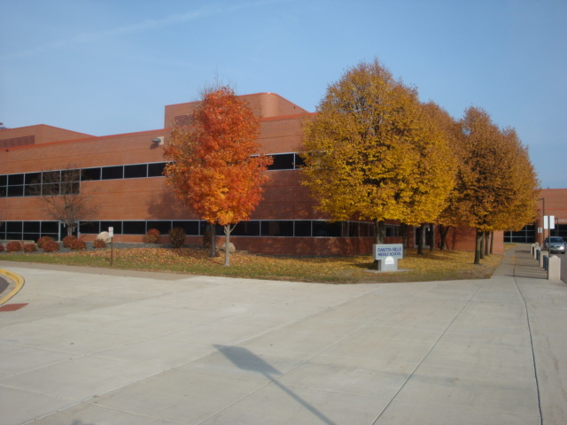

**Dakota Hills Middle School**

**4183 Braddock Trail**

**Eagan, MN 55123**

**www.district196.org/dhms/**



Welcome to Dakota Hills Middle School. We are a school of just over 1,200 students located in Eagan, a southern suburb of the Twin Cities. We have a dynamic staff of educators who love children, identify with young adolescents, and are committed to the success of each student. Over 70 percent of our teachers hold advanced degrees. Most importantly, all of our teachers exhibit a great passion for both their students and class subject areas.

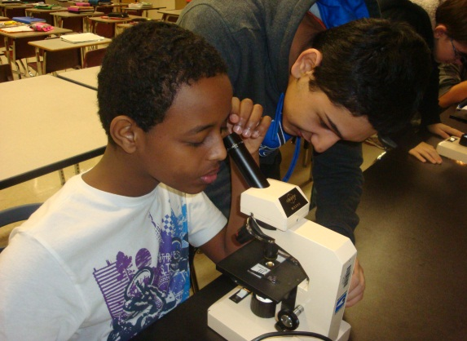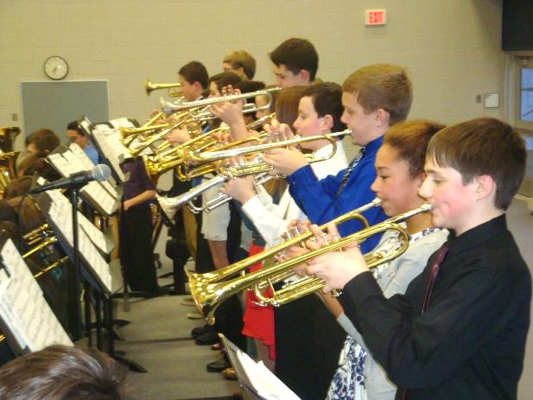Dakota Hills offers enthusiastic and challenging instruction by teachers who focus on personal relationships with students. Students experience a balance of challenge and support with high expectations within a nurturing environment. Our students consistently earn scholarly honors distinguishing Dakota Hills as a school that scores at or among the top schools in reading, math, and science assessments for both Minnesota and the metropolitan area. Our students move on to Eagan High School as the next step in their college preparatory or vocational learning.

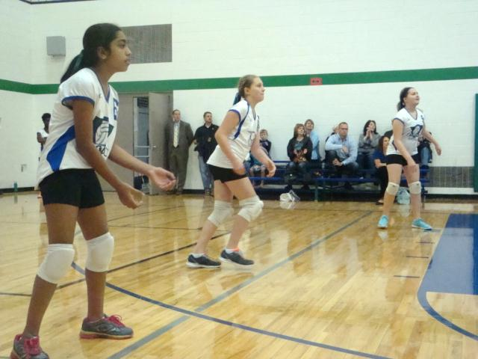Understanding that all young adolescents experience amazing cognitive, physical, and emotional during their three years at Dakota Hills, we are attentive to the academic and social-emotional needs of our students. We have active Parent and Site Councils that help us to stay connected and attuned to our community. We are blessed with a supportive Eagan community as our parents are interested and involved in the learning and growth of the children at DHMS. When you enroll your child at Dakota Hills, you will become members of our engaged, supportive, and close-knit educational family.

Dr. Trevor Johnson, Principal

**Dakota Hills Middle School**

*A commitment to be the best, and have fun along the way*

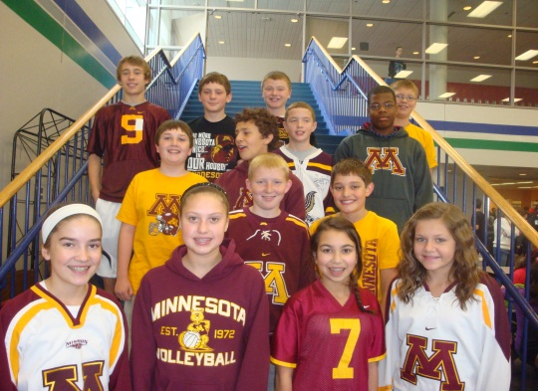

**Administration**

● Principal: Trevor Johnson, Ed.D.

● Assistant Principal: Jim Roberts

● Assistant Admin: Melissa Tapper



**Dakota Hills at a Glance** (2019-20 information)

**Contact Us School Day (6 class periods)**

(651) 683-6800 8:00 AM to 3:00 PM

4183 Braddock Trail Office Hours:

Eagan, MN 55123 7:00 AM to 3:30 PM

www.district196.org/dhms/

**Demographics** (2018-19 MDE Data)

● Total enrollment 1,223

● Asian 147 (12%)

● Black 60 (7%)

● Latino/Hispanic 141 (12%)

● Native American 1 (0.1%)

● White 788 (64%)

**School Highlights** (for 2019-20)

● Rigorous college-prep curricula

● More than 24 club activities

● 1-to-1 iPads for all students (provided by school)

● Gifted and Talented student program options

● Chromebook Wi-Fi browser and iPad application options

● Fine Arts/Performing Arts options

● Parent Involvement Opportunities

● 11 sports options: Fall-Winter-Spring

● Fall Drama and Spring Musical Performances

● After-school homework help labs (Monday thru Thursday)

● Daily advisory and academic support time

**Summary of Student Testing Data** (Spring, 2019 Scores)

● 70% met or exceeded proficiency on the MCA-III reading assessment

● 69% met or exceeded proficiency on the MCA-III math assessment

● 63% met or exceeded proficiency on the MCA-III science assessment

**Sample Schedules**

**7th:** Thirteen electives options in Music, French, Spanish, Tech Ed, FACS, and Art

**8th:** Thirteen elective options in Music, French, Spanish, Tech Ed, FACS, Art, PE, Debate and Coding

**6th:** Music options are band, choir, or general music